# Magnetic positioning sensor in electronics industries

Automation task using pneumatic cylinders equipped with magnetic position sensors (MPS) are gaining popularity in electronics industries, especially the manufacturing sector. Unlike cylinders using standard magnetic sensor that detects only ON-OFF status position, the magnetic position sensor (MPS) can measure linear position of the piston in cylinders. As manufacturing processes get more demanding, ON-OFF status is no longer adequate. The system needs continuous feedback of pneumatic piston position for this sophisticated tasks realisation. Some of such are like sonotrode control in ultrasonic welding machines, requires pneumatic system with MPS to operate effectively.

Traditionally, designers use various types of linear measurement sensors. These sensors are mechanical parts that follow, and measure directly the piston stroke. Firstly, industrial ingress protective IP can become an issue with this displacement sensors. Besides, such sensors are often designed for a vast number of applications, special mounting brackets are required. Most important, linear sensors are mechanical moving parts which are subjected to operating wear and tear.

Using MPS in measuring piston linear displace is gaining popularity due to the accuracy, simplicity, robustness and cost effectiveness. Robustness-wise, the MPS involves no moving parts, and therefore not subjected to mechanical wear and tear. Simplicity-wise, the MPS is designed to be mounting on most cylinders directly through the housing slots, thereby obsoleting the mounting brackets. More interesting, the MPS is optimise for cylinder linear measurement, and therefore can be cost effective. Other notable features are that the MPS are rated IP67, which means that it can be used in harsher environment within the electronic industries.

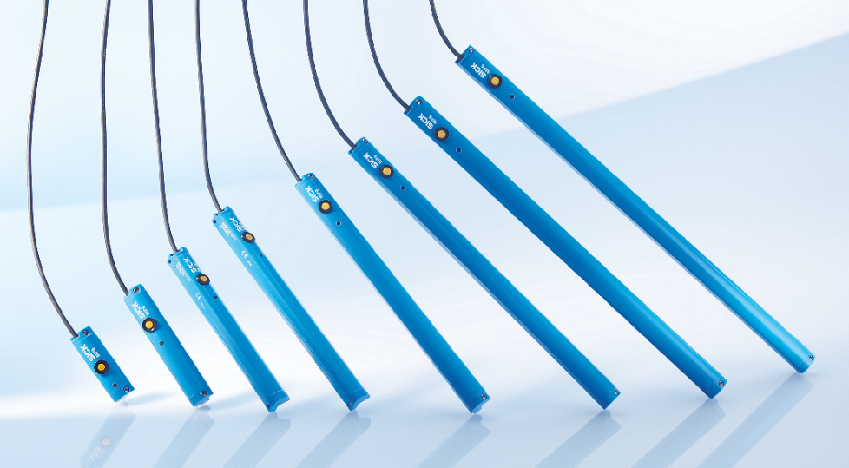

Technology-wise, the MPS discussed here is an advanced microprocessor based sensors for pneumatic cylinders, electrical cylinders, grippers and slides. Inside the sensor housed a row of Hall-effect sensors who “monitors” the cylinder’s piston. Raw analog inputs from each hall sensor are sampled and converted by the internal conversion circuitries, and then an internal powerful microprocessor will compute the magnetic piston head position in two steps:

1. Compute the external elements or stray noises in immediate vicinity, and suppress them.
2. Then calculate the piston head position with complex algorithm, and provides a linear output to the mother system in analog voltage output of 0…10V, and analog current output of 4…20mA.

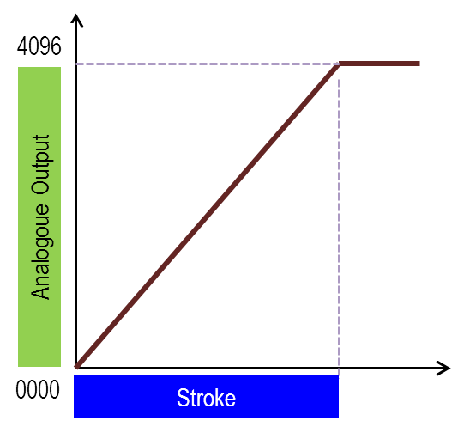

The MPS resolution, or smallest step change, can be represented in 4096 steps. Suppose we have a piston stroke of 40mm, the resolution of the MPS can be as tiny as 0,010 mm which is 40mm/4096steps. Suppose another MPS of 64mm measuring range is used, the the resolution will be 64mm / 4096 steps, which is 0,015mm/step.

Application-wise, the MPS is able to measure the cylinder stroke ranging from 32mm to 256mm. It is can be mounted on the popular T-slot pneumatic cylinders, and no additional adaptors are required. For other slots, mounting accessories are easily available in the market. Site commissioning is straightforward as indicative LEDs are present to guide the designers on triggering points. Additional teaching functions are available to designers to calibrate the required operating range.

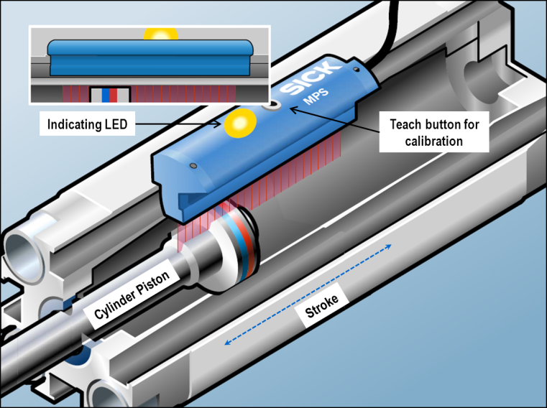

Applications for MPS in pneumatic system for electronic industries are plentiful, and increasing. Some common task of MPS-based pneumatic system includes orientation and positioning, thickness measurement, assembly, inspection. Common applications in electronics industries are:

* PCB detection
* SMT component placement
* Ultrasonic welding machines

# Printed Circuit Board Detection.

In SMT component assembly machine, a simple application using MPS is to detect if two printed circuit boards (PCB) are “sticking together” on conveyor belt which the blank PCBs travel. The concept is straightforward. The MPS are calibrated to detect the thickness of each PCB. Prior to component placement, each PCB is sampled by reading the MPS value to check the PCB thickness, which co-relates to the piston position. If abnormal pneumatic piston’s position is detected, the corrective action processes of the system can be triggered to prevent further faults. This simple concept provides a cost-effective solution to prevent costly machine downtime or material damages due to “sticking PCB”.



# SMT Pick & Place

SMT (surface mount technology) component placement systems are robotic machines which are used to place surface-mount devices (SMDs) onto PCB. They are used for high speed, high precision placing of broad range of electronic components. These systems normally use pneumatic suction cups, attached to a plotter-like device to allow the nozzle head to be accurately manipulated in three dimensions. Here, MPS is used to acquire rapid accurate dimensional feedback of pistons’ position, which correlates to the SMD placement on the PCBs. In addition, the MPS can provide a high sampling rate of upto 1.5 millisecond for partial-stroke piston operation.

C:\Documents and Settings\chanch\Desktop\White paper 2013\Semconductor backend processing.TIF

# Ultrasonic welding

In the electronics industry, industry ultrasonic welding is often used to join wired connections and to create connections in small, delicate circuits. Junctions of wire harnesses are often joined using ultrasonic welding. It is also often preferred in the assembly of storage media such as flash drives and computer disks because of the high volumes required.

In MPS-based ultrasonic welding system, the position sensor provides detail feedback so that high accuracy control of the sonotrode is ensured. This is very important for high quality connection of the materials. With the position sensor, no mechanical adjustment for tolerance of workpiece is needed. In addition, users have the flexibility to implement sophisticated task as they can adjust the control ranges from 32mm to 256mm.



# In conclusion

With increasing numbers of tasks in the electronic industry demanding more rapid and precise inputs other than ON-OFF status, the magnetic position sensor (MPS) are set to enable many standard automation system to perform more sophisticated tasks at another level. Using the dimensional feedback signals from MPS, many standard automation system can be now programmed to perform more precise, or more accurate, or more speedier roles. Many key applications in electronics industries can benefit vastly adopting the MPS in their automation task. Examples are ultrasonic welding, SMT assembly etc. In additional, designers, who traditionally uses the more costlier displacement sensor solution, can reap the cost-reduction benefits by switching to this MPS.

**Author :**

*Mr Chris Chan*

**Product Manager**

**Business Unit Sensors & Connectivity**

**Presence Detection**