SICK presents interactive “Solutions for Cleaner Industries”
Düsseldorf / Waldkirch, July 2022 – Innovative technologies for emission monitoring and clean energy sources, precision process measurement technology for efficient production processes as well as digital Smart Services for condition monitoring and predictive maintenance of plants will be the focus of SICK's trade show attendance at Achema 2022 (Hall 11.1, Booth A85). All four of these thematic areas will be presented interactively in virtual applications on various touch terminals. The highlight of the trade fair booth is the opportunity to experience via virtual reality the environment of a waste incineration plant in order to get to know MCS200HW multi-component analyzer system for flue gas monitoring.
As a technology leader in emission measurement technology, SICK will be presenting itself also as a competent partner for climate-friendly and sustainable equipping and upgrading of plants in the process industry. At the same time, Digital Services provide efficient solutions for real time monitoring and maintenance of analyzers and sensors in industrial plants for a variety of applications and industries.
Experience and operate the MCS200HW multi-component analyzer system virtually
Experience, operate, and master analytical technology live – this is what the virtual reality exhibit for the MCS200HW allows. It offers visitors the opportunity to familiarize themselves with the functionions of the multi-component analyzer system, which can continuously monitor up to ten IR measuring components in the flue gas of industrial combustion plants. Visitors can, for example, query the operational status of the device, view error messages or service requests, or carry out maintenance steps themselves using a joystick. The VR application also demonstrates how error patterns can be diagnosed in a timely manner by monitoring specific parameters. This allows – virtually and also in real-life applications – targeted and efficient troubleshooting.
A further product highlight at SICK’s trade fair booth is the officially approved FLOWSIC600-XT and FLOWSIC500 ultrasonic gas meters approved for custody transfer. Both gas meters are ready for new energy carriers such as hydrogen. This is because both device types can measure the volume in natural gas with hydrogen contents of up to 30% for custody transfer purposes. Thanks to the integrated innovative gas quality indicator, the hydrogen concentrations can be monitored decentrally and in real time.
Experience Solutions for Cleaner Industries interactively
Emission monitoring (clean combustion), clean energy sources (clean energy), process measurement technology (process solutions) as well as digital solutions and smart services (digital solutions & smart services) are the four cleaner industries themes under which SICK has positioned itself as a process industry partner. A series of applications will be presented virtually and in 3D at several touch terminals. Visitors can also access additional information, view theme-related videos – and are welcome to strike up a conversation with the experts at SICK. For additional information about the trade fair appearance, please visit the landing page at www.sick.de/achema.

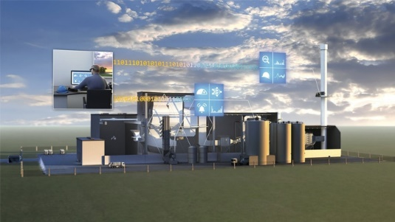
As an innovation driver and technology leader in the area of emission and analytical measurement technology, SICK will be presenting itself as a competent partner for climate-friendly and sustainable equipping and upgrading of machines and plants in the process industry.

Contact
Melanie Jendro │PR manager │melanie.jendro@sick.de
+49 7681 202 4183 │+49 151 741 035 31

SICK is one of the world’s leading solutions providers for sensor-based applications in the industrial sector. Founded in 1946 by Dr.-Ing. e. h. Erwin Sick, the company with headquarters in Waldkirch im Breisgau near Freiburg ranks among the technological market leaders. With more than 50 subsidiaries and equity investments as well as numerous agencies, SICK maintains a presence around the globe. In the 2021 fiscal year, SICK had more than 11,000 employees worldwide and a group revenue of around EUR 2 billion. Additional information about SICK is available on the Internet at http://www.sick.com or by phone on +49 (0)7681202-4183.

