Industry 4.0 for the shop floor: SARA (SICK Augmented Reality Assistant) improves availability and productivity
App opens up new possibilities for commissioning, service and diagnostics using mobile devices

Waldkirch, May 2022 – More efficiency during commissioning and maintenance, faster troubleshooting thanks to visualization and localization of faults on a smartphone or tablet, direct support for shop floor employees without waiting for expert help – the SARA (SICK Augmented Reality Assistant) app redefines commissioning, service, and diagnosis. This is because SARA, one of the first solutions of its kind for industrial environments, connects sensor data and real environments, thereby visualizing process and diagnostic information directly where it is generated: on the shop floor. The app gives on-site staff direct and immediate assistance with sensor parameterization and diagnostics. This saves time, shortens machine downtime and increases availability and productivity.
A robot stops for an unknown reason, an AGV system just stays in place during transport travel, a machine switches off for no apparent reason – these are all classic scenarios in which SARA can significantly simplify and speed up targeted cause diagnostics and troubleshooting. Using augmented reality, the app merges the sensor field of vision with its real environment and visualizes the reason for the fault directly on a mobile device. The user is shown the device data from the sensor perspective in the real environment, without an additional laptop, PC or software tool.
In a similar way, SARA also provides support for commissioning 3D LiDAR sensors on automated guided vehicles and mobile carts, for example. The app displays the configuration results directly on a smartphone when teaching in and visualizing scan and protective fields on site. The time and location of field violations are then documented during operation: this allows for precise analysis of the causes of faults. SARA can also display any other data, such as the device ID, temperature, operating hours, charge status of the vehicle battery or the degree of contamination of sensors, which rounds out the diagnosis process.
Root cause analysis made easy
SARA works with nearly any SICK sensor with integrated data interface. To start troubleshooting, the user first identifies the SICK sensor technology by scanning a 2D marker on the machine. SARA then virtually augments the camera image of the scene using augmented reality with the set sensor parameters, such as the size and geometry of set scan fields. The operator can immediately see when, where and how field violations have occurred that have caused the machine to stop, and can usually eliminate these causes right away. This is how SARA helps to accelerate recommissioning, thus minimizing the downtime of robots, automated guided vehicles and machines.
No cloud connectivity required
SARA is not a cloud app. The application is installed directly on a smartphone or tablet with an iOS or Android operating system as well as in the customer IT infrastructure. As a result, SARA can be integrated seamlessly into existing safety concepts and also be easily maintained and serviced by the company IT department.
Product launch with basic package and LiDAR package
SARA is currently available in two equipment packages. The basic package includes all the software tools, markers, templates, and supplementary components needed to implement universal applications. Also included in the package is installation and commissioning service by SICK, as well as a floating license with no time limit. The LiDAR package for the microScan and nanoScan LiDAR sensors as well as for numerous TiM and LMS variants from SICK provides device type-specific visualization and control elements for the screen interface. The user can purchase an unlimited number of floating licenses for the SARA system, each one limited to twelve months, and renew them after that time. The number of licenses corresponds to the number of users who can work with SARA at the same time.
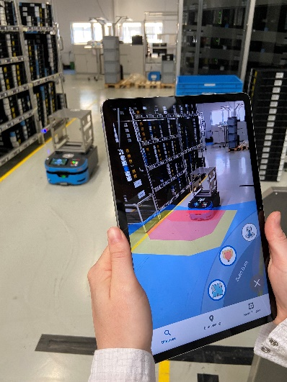

The SARA (SICK Augmented Reality Assistant) app opens up new possibilities for commissioning, service and diagnostics using mobile devices

Contact
Melanie Jendro │PR Manager │melanie.jendro@sick.de
+49 7681 202-4183 │+49 151 741 035 31

SICK is one of the world’s leading producers of sensors and sensor solutions for industrial applications. Founded in 1946 by Dr.-Ing. e. h. Erwin Sick, the company with headquarters in Waldkirch im Breisgau near Freiburg ranks among the technological market leaders. With more than 50 subsidiaries and equity investments as well as numerous agencies, SICK maintains a presence around the globe. In the fiscal year 2021, SICK had almost 11,000 employees worldwide and achieved group sales of around EUR 2 billion. Additional information about SICK is available on the Internet at http://www.sick.com or by phone at +49 (0)7681202-4183.

