Without instruction: AGCs navigate independently with the multiScan1xx
Waldkirch, February 2023 – SICK launches the compact and precise multiScan100 3D LiDAR sensor. This is one way the company is supporting the development of autonomous industrial vehicles both in- and outdoors and increasing its focus on digital software solutions to offer customers additional benefits beyond pure measurement data.
At the last SPS in Nuremberg, visitors had a chance to get a first look at the new multiScan100 product family, which is designed as a contour navigation system for industrial vehicles. With the first variant, the multiScan136, mobile platforms such as AGVs or service robots can independently explore a new environment and generate a map that can be used for navigation and localization during productive operation. The LiDAR sensor delivers 3D measurement data combined with a high-resolution 0° scan plane, which can be used for precise self-localization of autonomous vehicles while simultaneously mapping the environment (SLAM, which stands for simultaneous localization and mapping). The 3D point clouds can also detect fall edges or obstacles in 3D.
The multiScan136 3D LiDAR sensor with 360° vision achieves state-of-the-art precision thanks to up to 690,000 measuring points – nothing in its environment gets by it. With its compact design of approx. 10 cm in size and industrial interfaces, it is very easy to integrate. The sensor can be used in harsh environments thanks to its rugged design and IP protection class of up to 69k. The proven multi-echo technology and its statistical measurement procedure ensure precise environment perception, even under poor outdoor conditions. This means that, thanks to its high measurement accuracy and low measurement noise, the multiScan136 can be used not only for precise fine positioning indoors, but also for environment perception outdoors. With the large vertical aperture angle of 65°, nothing goes unnoticed, which helps to avoid collisions when using mobile outdoor automation. In addition to mobile applications, the sensor can also be used for stationary object protection applications for building security, or for traffic or smart city applications such as people flow detection thanks to its large field of view.
With the multiScan136, SICK is advancing its 3D LiDAR technology and increasing its focus on digital software solutions to offer their customers additional benefits beyond pure measurement data. That means the precise measurement data is only the first step to creating additional functions that can be evaluated directly on the sensor without an additional computing unit.

Images:
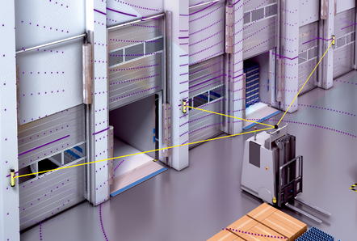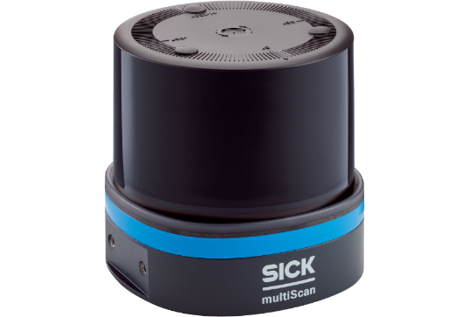
Without instruction: With the multiScan136, mobile platforms can independently explore a new environment and generate a map.

Contact
Melanie Jendro │PR Manager │melanie.jendro@sick.de
+49 7681 202 4183 │+49 151 741 035 31

SICK is one of the world’s leading solutions providers for sensor-based applications in the industrial sector. Founded in 1946 by Dr.-Ing. e. h. Erwin Sick, the company with headquarters in Waldkirch im Breisgau near Freiburg ranks among the technological market leaders. With more than 50 subsidiaries and equity investments as well as numerous agencies, SICK maintains a presence around the globe. In the 2021 fiscal year, SICK had more than 11,000 employees worldwide and a group revenue of around EUR 1.9 billion. Additional information about SICK is available on the Internet at http://www.sick.com or by phone on +49 (0)7681202-4183.

