Sensor intelligence profits from deep learning

SICK delivers new sensor functions

Waldkirch, April 2019 – At the Hannover Messe 2019, SICK will present its new software applications based on deep learning algorithms. Starting now, users of system solutions in logistics automation can profit from the benefits of the new technology.

Using deep learning, sensors perform intelligent in the automated detection, testing and classification of objects or features, which were reserved for humans so far. Deep learning, a sub-area of machine learning, ranks among the probably most significant future technologies in the field of artificial intelligence, and is a long-term driver of Industry 4.0 at the same time. After SICK reported the successful application of deep learning algorithms in the first pilot programs in January, the company is now announcing a new software application for system business in logistics automation based on deep learning at the Hannover Messe. In this application, the deep learning system detects whether a sorting tray in a logistics hub is actually loaded with only one object. This makes the stream of goods more efficient.

Training for the sensor
Neuronal networks are used to realize deep learning. Compared to the classical process for developing algorithms, which is mainly characterized by manual development of a suitable feature representation, a neuronal network is trained to optimal features for its task and can be retrained again and again with suitable data in order to adapt to new circumstances.
SICK is using a powerful, independent in-house computer and IT base as the executing unit both for development of the training data set by collecting and assessing thousands of images and examples as well as for training the neuronal networks. The extensive computation of the complex operations of the deep learning solution for training is done on computers with high GPU performance specially equipped for this purpose. The new deep learning algorithms generated in this way are provided locally on the sensor, making them fail-safe and directly available, for example on an intelligent camera.

Development of the deep learning sensor portfolio
With the implementation of deep learning in selected sensors and sensor systems, SICK is igniting the next level in AppSpace after the SICK AppSpace eco-system–a new sensor software concept which creates adaptable and future-proof solutions for automation applications. Other image-processing sensors and cameras are naturally also included in the coming products, which work with the new technology and whose customer-specific adaptation generates real added value for the user. The concept of the sensor specialized with artificial intelligence can be used principally on simple sensors such as inductive proximity sensors, photoelectric retro-reflective sensors, ultrasonic sensors and others. In addition, system solutions such as increasingly challenging vehicle classification at toll stations offer potential for a deep learning-supported classification of vehicles into toll classes.

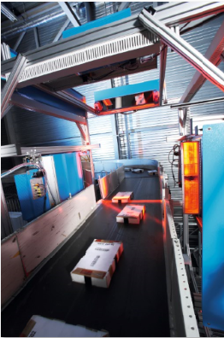 SICK_DL_Logistik_0039849
Based on deep learning, the SICK application system detects whether a sorting tray in a logistics hub is actually loaded with only one object.

Contact
Melanie Jendro │PR manager │melanie.jendro@sick.de
+49 7681 202 4183 │+49 151 741 035 31

SICK is one of the world’s leading producers of sensors and sensor solutions for industrial applications. The company, which was founded in 1946 by Dr. Erwin Sick and has its headquarters in Waldkirch im Breisgau near Freiburg in Germany, is among the technology market leaders. With more than 50 subsidiaries and equity investments as well as many agencies, SICK has agencies all over the world. In the 2017 fiscal year, SICK had more than 8,809 employees worldwide and a group revenue of just under EUR 1.5 billion.
Additional information about SICK is available on the Internet at http://www.sick.com.

