TRUMPF and SICK develop the first industrial quantum sensor

Cooperation agreement on development of industrial quantum sensor signed // Successful functional test of the world’s first quantum optical sensor for serial production // First sensors in industrial use from 2021 // Experts estimate total market for quantum sensors at about EUR 1.1 bn. by 2023

Ditzingen/Waldkirch, 5 November 2020 – The wholly-owned TRUMPF subsidiary Q.ANT and sensor specialist SICK will in future work together on the development of quantum optical sensors. Representatives of the two high-tech companies signed a cooperation agreement today to make quantum technology for sensors available for industrial use. Quantum sensors enable measurements with unprecedented accuracy. The signing was preceded by a successful functional test of the world’s first quantum optical sensor for serial production. “SICK is expanding its position as a worldwide technology leader in the sensor sector by embarking on the production of quantum sensors. Quantum sensors are a key technology for the future of industry,” says Robert Bauer, Chairman of the Executive Board of SICK AG. As a market and technology leader for industrial sensors, SICK will be responsible for application development and sales of the product. As a specialist in quantum technology, the TRUMPF subsidiary Q.ANT takes on production of the measurement technology – and thus the sensor’s core technology. “Quantum technology is an enormous opportunity for German and European industry. This will be the first time that the partnership between our two high-tech companies will involve a product for serial production. The quantum sensor enables highly accurate measurements, and will provide insights that will lead to completely new industrial applications,” says Peter Leibinger, Chief Technology Officer at TRUMPF. The first use of the new quantum sensors is planned for 2021.

Highly precise measurements of the smallest of particles
Quantum sensors have hitherto mainly been used in research. For the first time, Q.ANT and SICK have now successfully completed functional tests for an industrial application. “Quantum technology enables, for example, ultrafast measurements of the movement and size distribution of particles. With industrialization of these sensors, not just us but Germany – as a high-tech location – takes a major step towards the commercialization of quantum technology,” says Michael Förtsch, CEO of Q.ANT. Using laser light, quantum sensors permit highly efficient measurements that would be impossible with conventional processes. “Quantum technology is the next level for sensors because it shifts hitherto firmly established technical limits. Using quantum effects, additional details can be perceived from signal noise where, up to now, no specific signals would have been measureable. This enables the measurement of particles that are about two hundred times smaller than the width of a human hair,” says Niels Syassen, Senior Vice President R&D at SICK and responsible for the project there. The quantum sensors will initially be used for analyzing substances in air.

Industrialization leads to increased market volume
Quantum sensors could in future become everyday equipment in various industries: For example, they could be used in civil engineering to visualize underground structures before construction work begins; in the pharmaceutical industry they could make it easier to determine the best composition of tablet powder; in the electronics sector circuits could be inspected through surfaces; and highly accurate measurements could be made in industry in general. The market for quantum sensors could grow steadily with industrialization. Experts at Germany’s National Academy of Science and Engineering (Acatech) estimate the worldwide market volume of industrial quantum sensors at about EUR 1.1 bn. by 2023.
Q.ANT is a wholly-owned subsidiary of TRUMPF and is based in Stuttgart. The start-up employs about 15 personnel and makes quantum technology suitable for daily use with the help of new photonic technologies. TRUMPF has been using SICK sensor solutions in its production and logistical processes for many years so the new cooperation on quantum technology builds upon a well-founded technological partnership.

Appropriate digital images are available for this press release in a printable resolution. They may only be used for editorial purposes. Use is free of charge with the source reference “Photo: TRUMPF”. No graphic alterations are permitted except to crop the main motif. More photos can be obtained from the TRUMPF Media Pool.

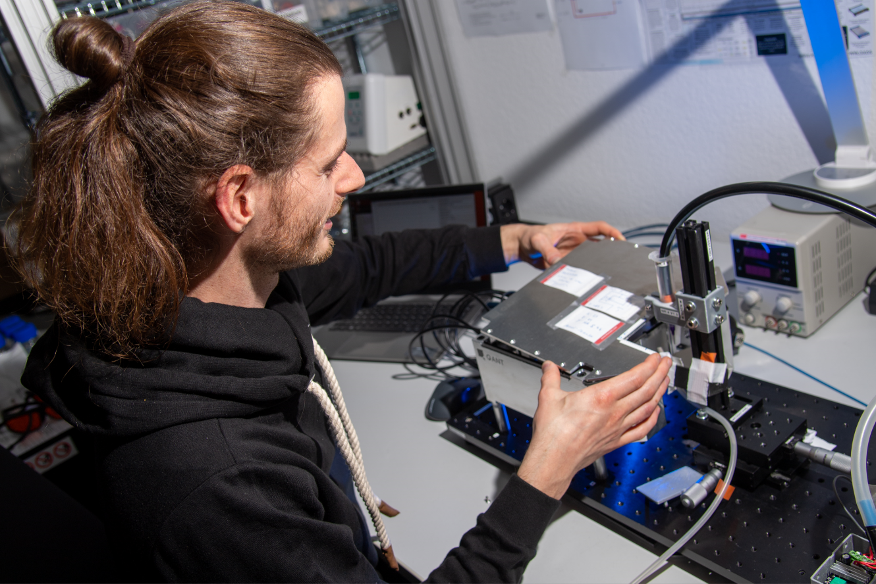 |  | Quantum sensor measuring stand  Q.ANT and SICK are jointly developing quantum sensors for industry. A Q.ANT employee is checking the overall functionality of the sensor at this measurement stand.
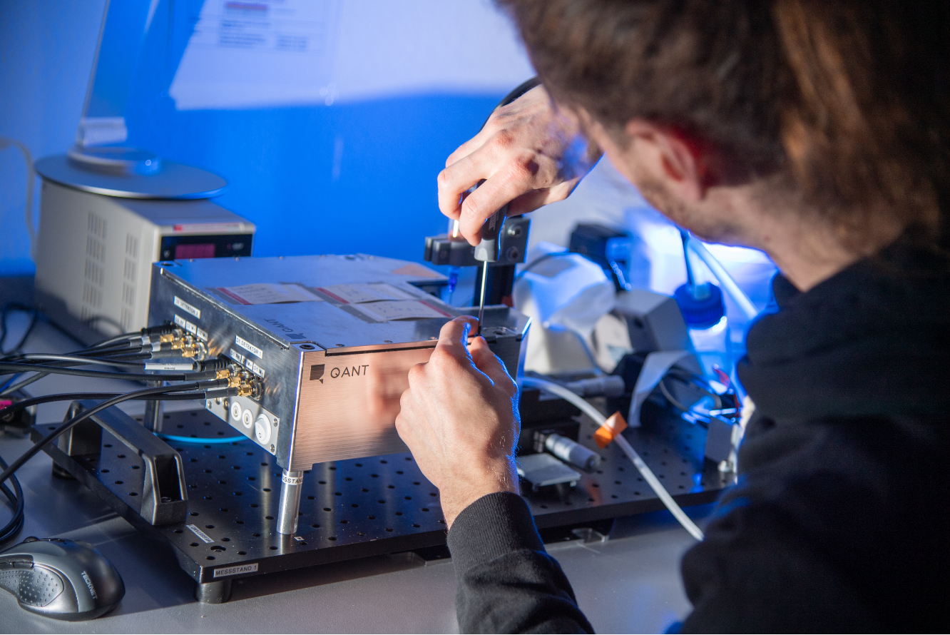 |  | Optical signals quantum sensor  The first functional tests of the new quantum sensor from Q.ANT and SICK were successful. Here an employee is testing the sensor’s optical signal.
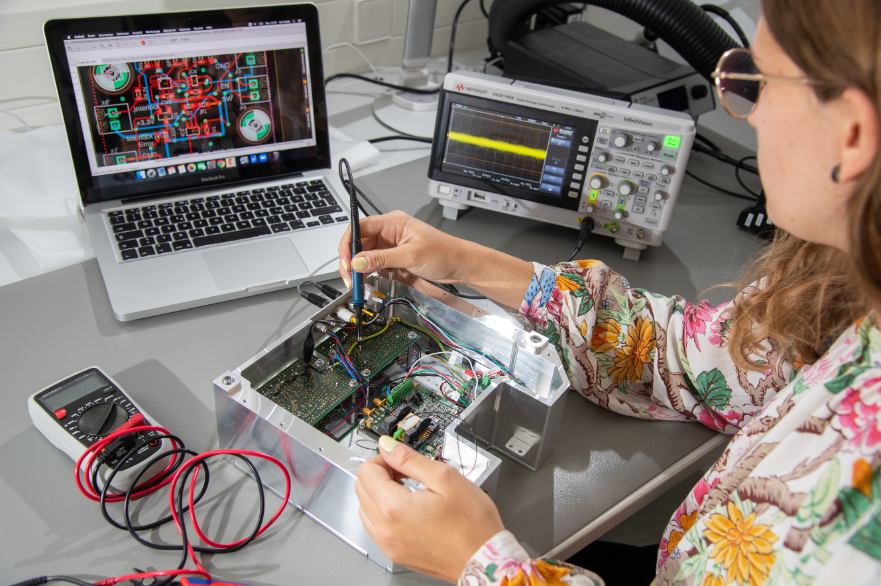  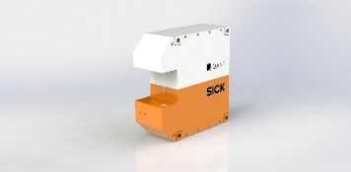 |  | Electronic signal processing quantum sensor  Quantum sensors enable measurements with an accuracy that has hitherto been technically impossible. Here an employee of Q.ANT is testing electronic signal processing.  The QuantAlyzer  High-precision measurements, new applications in industry: the quantum sensor from Q.ANT and SICK will be tested with customers for the first time in 2021.

About SICK

SICK is one of the world’s leading suppliers of solutions for sensor-based industrial applications. The company, founded by Dr. Erwin Sick in 1946 and based in Waldkirch-im-Breisgau near Freiburg, is a technology and market leader with a global presence – with more than 50 subsidiaries and associated companies, as well as numerous sales offices. SICK achieved Group sales of about EUR 1.8 bn. in 2019 with more than 10,000 employees worldwide.

More information on SICK is available at www.sick.com

About TRUMPF

The high-tech company TRUMPF offers production solutions involving machine tools and laser technology. The company drives forward the digital networking of manufacturing industries with platform and software solutions, as well as consulting. TRUMPF is a technology and market leader for industrial lasers and machine tools for the flexible processing of metal sheets. The company achieved sales of EUR 3.5 bn. during the 2019/20 fiscal year with about 14,300 employees. With more than 70 subsidiaries, the Group maintains a presence in almost all European countries, in North and South America, and in Asia. There are production sites in Germany, France, the UK, Italy, Austria, Switzerland, Poland, the Czech Republic, the USA, Mexico, China and Japan.

More information on TRUMPF is available at www.trumpf.com

Press contacts:
Dr. Manuel Thomä
Manager Media Relations TRUMPF
+49 (0)7156 303-30992
Manuel.Thomae@TRUMPF.com

Melanie Jendro
Public Relations Manager SICK AG, Innovation
+49 (0)7681 202-4183
melanie.jendro@sick.de

Diana Kuch
Public Relations Manager SICK AG, Company
+49 (0)7681 202-5747
diana.kuch@sick.de

[Further information, e.g. links to websites, customer magazines, contacts, etc.]

